***Virginia Junior Classical League***

*presents this*

Certificate of Excellence

*to*

Jessica Smart

*of*

Mountain View High School

*for*

*5th Place in Small Models*

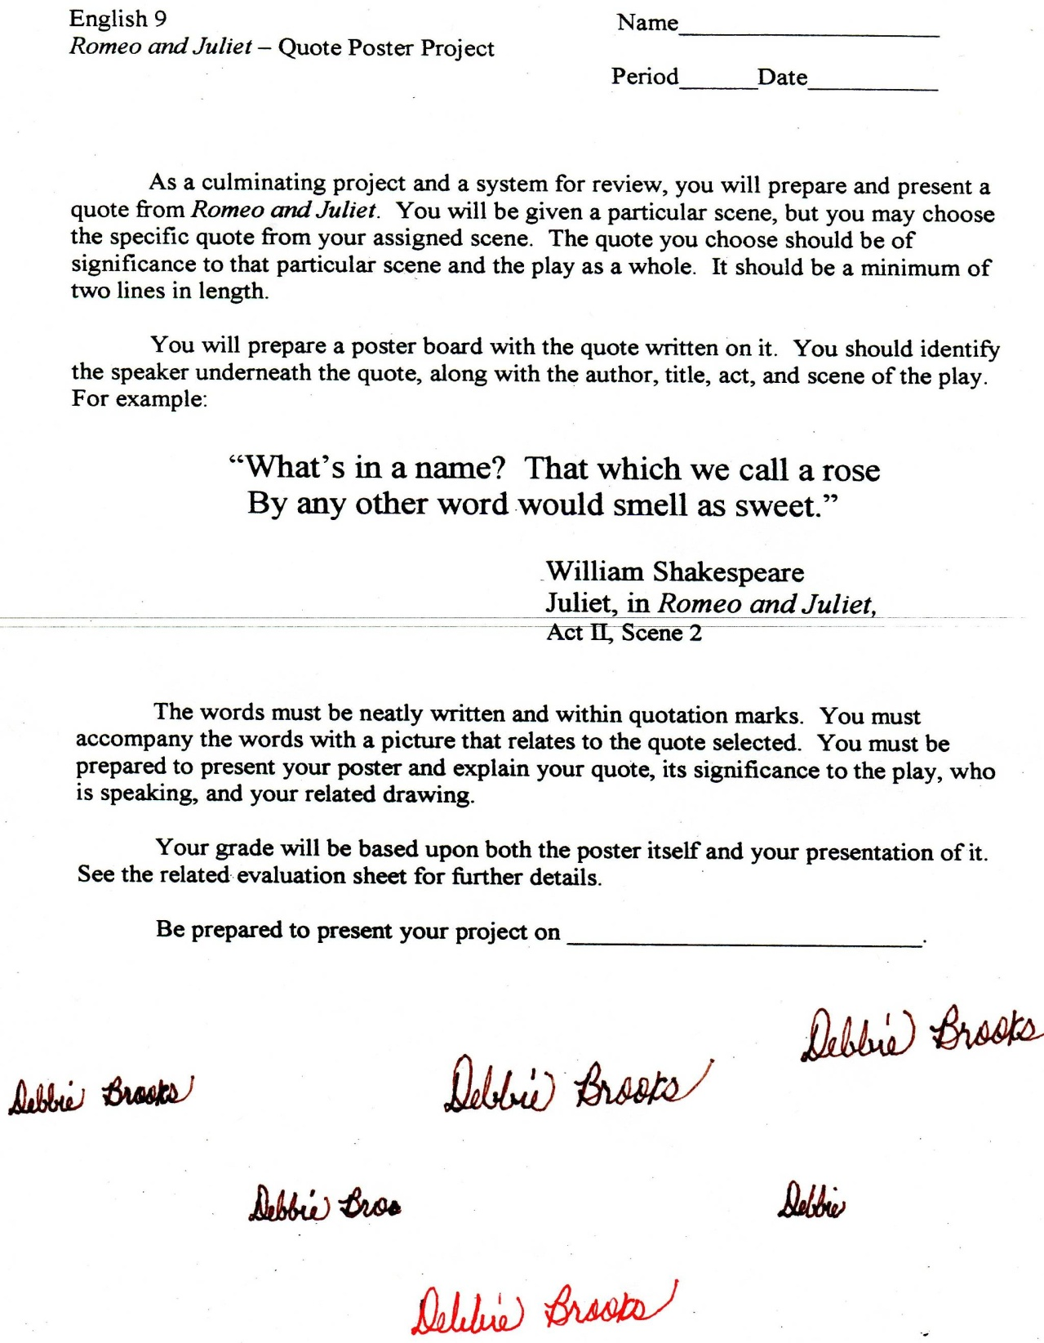

Microsoft Office Signature Line...

*a.d. viii Kal. Dec. MMDCCLXVII A.U.C. 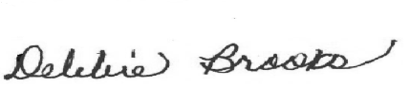*

***Virginia Junior Classical League***

*presents this*

Certificate of Excellence

*to*

Lyndsey Czzowitz

*of*

Mountain View High School

*for*

*6th Place in Pentathlon*

**

Microsoft Office Signature Line...

*a.d. viii Kal. Dec. MMDCCLXVII A.U.C. *

***Virginia Junior Classical League***

*presents this*

Certificate of Excellence

*to*

Lexi Dahlke

*of*

Mountain View High School

*for*

*6th Place in Storytelling*

**

Microsoft Office Signature Line...

*a.d. viii Kal. Dec. MMDCCLXVII A.U.C. *

***Virginia Junior Classical League***

*presents this*

Certificate of Excellence

*to*

Emily Hollis

*of*

Mountain View High School

*for*

*9th Place in Other*

**

Microsoft Office Signature Line...

*a.d. viii Kal. Dec. MMDCCLXVII A.U.C. *